JDK version - Just for reference

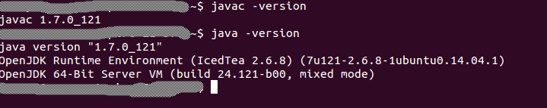

Step 1:

The same piece of code.

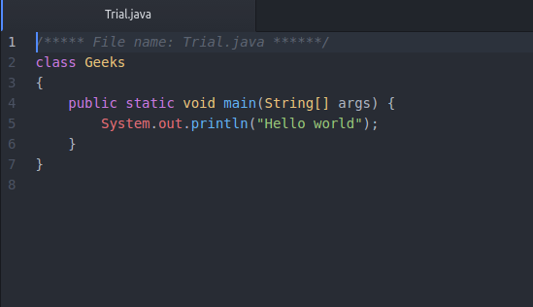
Step 2:

compiling the source code


this will create .class file in the name of class-Geeks which is mentioned in the source code.

Step 3:

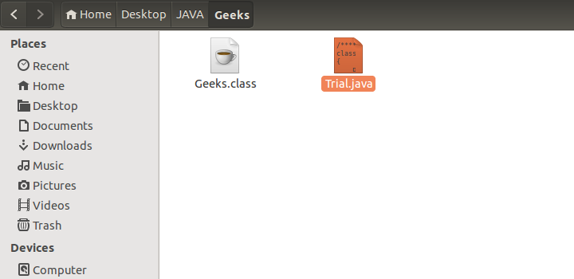

Step 4:

Now execute this class file to get the output

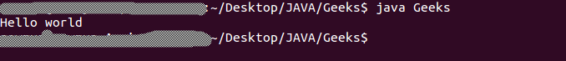

Executed without any errors

